(SCHOOL) Backpack Awareness (YR): How’d We Do?
Volunteers weighed the backpacks of over half of our student population (311 packs) on 9/21/16
Average Backpack Weight: 14.6 lbs
Good News: This is 1.5 lbs lighter than last year!!

Bad News: they are still TOO heavy. 92% of our students are NOT in the ‘safe zone,’ which is having a backpack that is less than 10-15% of your overall bodyweight (per AOTA & APTA guidelines).
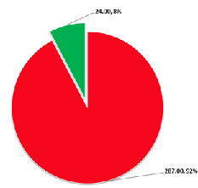
Please visit: (YOUR URL) to learn more about the steps the PTSA Backpack Committee, (SCHOOL) staff, LWSD and students are all doing to address this important issue.

